**HTML & CSS Beginner Assignment: "Healthy Smoothie Bar" 🍓🍍**

**Index.html**

<!DOCTYPE html>

<html lang="en">

<head>

  <meta charset="UTF-8">

  <title>Healthy Smoothie Bar</title>

  <link rel="stylesheet" href="Index.css">

</head>

<body>

  <h1 id="main-title">🍌 Healthy Smoothie Bar</h1>

  <div id="welcome">Fresh, Cool, and Healthy! 🥞</div>

  <p>Drink well. Feel well.</p>

  <h2>Our Smoothies</h2>

  <ul>

    <li id="list1" class="item">Mango Blast</li>

    <li class="item">Berry Power</li>

    <li class="item">Green Detox</li>

  </ul>

  <h2>Seasonal Specials</h2>

  <ul>

    <li class="item">Pineapple Paradise</li>

    <li class="item">Coconut Dream</li>

  </ul>

  <p>Stay fresh, come back soon! ✨</p>

</body>

</html>

**Index.css**

h2 {

  color: green;

  font-size: 18px;

}

#main-title {

  color: darkorange;

  text-align: center;

}

#list1 {

  color: teal;

}

.item {

  color: darkgreen;

}

#welcome {

  background-color: lightyellow;

  padding: 10px;

}

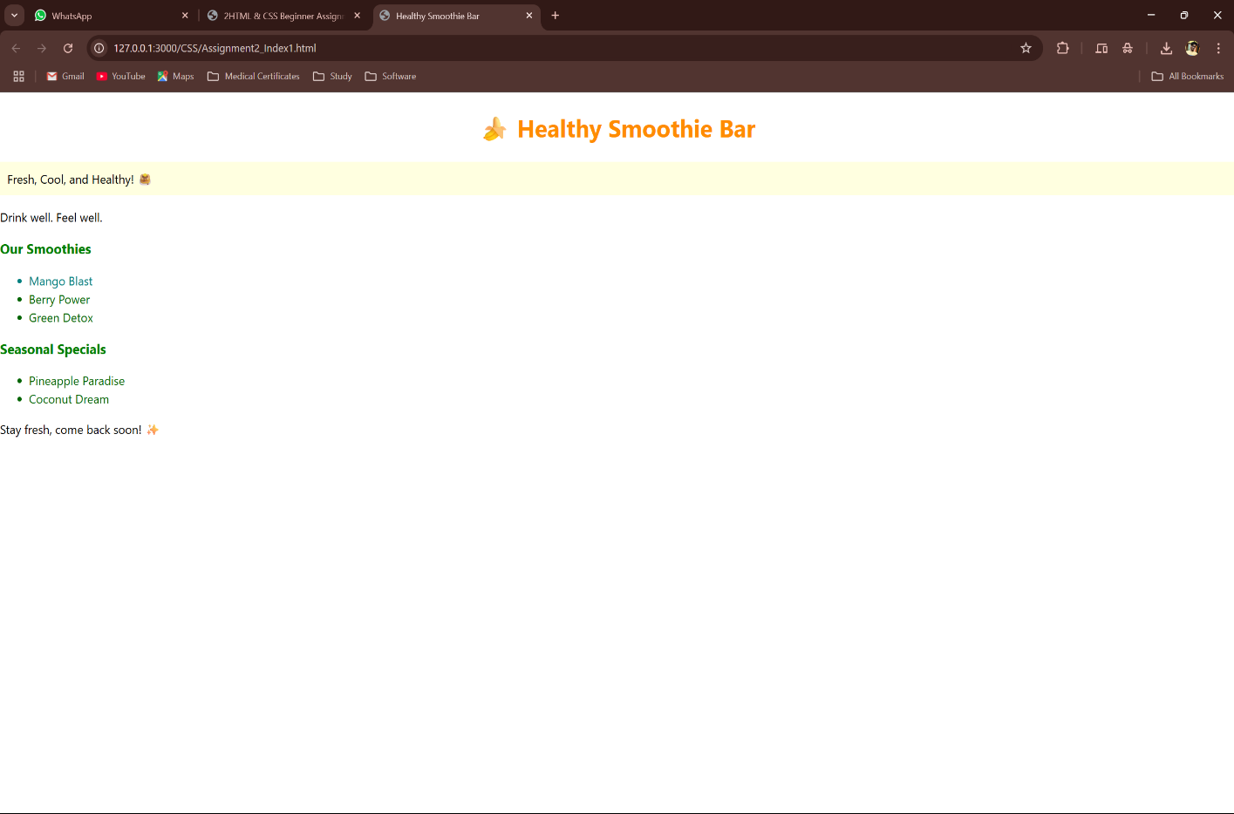

**HTML & CSS Practice with Selectors: "Book Store Website"**

**Index2.html**

<!DOCTYPE html>

<html lang="en">

<head>

  <meta charset="UTF-8">

  <title>BookNook</title>

  <link rel="stylesheet" href="Index2.css">

</head>

<body>

    <header>

        <h1 id="header-title">📖 BookNook</h1>

        <p class="tagline">A world of stories awaits.</p>

    </header>

    <div id="categories">

        <h2>Book Categories</h2>

        <ul>

            <li class="category">Fiction</li>

            <li class="category">Science</li>

            <li class="category">Biography</li>

        </ul>

    </div>

    <div class="highlight">

        <h3>Featured Book</h3>

        <p class="description">Explore our pick of the month.</p>

    </div>

    <div id="footer">

        <p>Thank you for visiting BookNook!</p>

    </div>

</body>

</html>

**Index2.css**

#header-title {

    color: darkblue;

    text-align: center;

}

.tagline {

    font-style: italic;

    color: lightgray;

    text-align: center;

}

#categories .category {

    color: green;

    font-weight: bold;

}

.highlight h3 {

     color: red;

}

.highlight .description {

    background-color: lightblue;

    padding: 10px;

}

#footer p {

    text-align: center;

    font-weight: bold;

}

